Steps to Restore Sql server Database

To restore your database, follow these steps:
- Open SSMS and connect to your SQL Server instance.
- Right-click the Databases node in Object Explorer and select Restore Database....
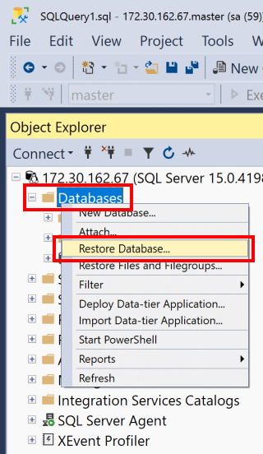
- Select Device, and then select the ellipsis button (...) to locate your backup file.
- Select Add and navigate to the location of your .bak file. Select the .bak file, and then select OK.
- Select OK to close the Select backup devices dialog.
- Select OK to restore your database.
